**SAP HANA Tutorial – Session #1**

* **Prerequisite**
* **Why choose SAP HANA**
* **Get SAP HANA DB**
* **SAP HANA Hardware**

**Prerequisite to learn SAP HANA**

* What are the prerequisite to learn SAP HANA?
* Is ABAP required to learn SAP HANA?
* I don't know SAP BW, SAP BO, SAP BI. Can I learn and make career in SAP HANA?
* Can people with varied background (JAVA, PHP, .NET, JavaScript, HTML etc.) and no prior SAP knowledge be able to succeed in SAP HANA?
* From where to start learning SAP HANA?
* How to get access to cost effective SAP HANA Server, SAP HANA Studio and other client tools?
* What are the SAP HANA certifications and how does it help in boosting my career?
* If I want to make a career in SAP HANA what is the roadmap?

**What are the prerequisite to learn SAP HANA?**

At its core, SAP HANA is like a relational database. You should know **Database Concepts** and should have **basic knowledge of SQL** before starting SAP HANA.

**Is ABAP required to learn SAP HANA?**

NO.  
The knowledge of ABAP may help in understanding the Business logic implementation. It is an advantage, but not mandatory.   
However if you are already an experienced ABAP programmer and thinking: “Whether ABAPer time has come to an end?” Then also you should not worry.   
There is a new ABAP - Which is SMARTER, LIGHTER and FASTER" - and at the bottom sits SAP HANA powering ABAP silently without any disruption. This is what we call "ABAP FOR SAP HANA".

**I don't know SAP BW, SAP BO, SAP BI. Can I learn and make career in SAP HANA?**

Let’s check it one by one.   
**SAP Business Information Warehouse (SAP BW):**   
Knowing BW helps you in understanding Modeling concepts and when you want DXC to transfer data from SAP Business Suite System to HANA.   
But even if you don't have the knowledge of BW, you can easily learn HANA Modeling concepts. BW knowledge is a must if you are going to work on BW on HANA.

**SAP BusinessObjects (BO):**   
BO or Business Objects is the Front end Reporting tool set from SAP.   
If you have knowledge of BO then reporting on HANA would be a piece of cake for you. But even if you don't have knowledge of BO, when you start learning HANA Concepts on Reporting you will be easily able learn BO concepts.   
  
You might want to gain the understanding of different reporting tools in BO (Explorer, WebI etc). There are many step by step guides that can help you to learn these tools.   
  
**SAP BI:**   
BI or SAP BI is the Data Warehousing package implementation tool from SAP. The realization of Data Warehousing Concepts in SAP BI will help understand the implementation aspects from BW on HANA perspective. Again unless you are planning to work on BW on HANA, you don't necessarily have to learn SAP BI.

Can people with varied background (JAVA, PHP, .NET, JavaScript, HTML etc.) and no prior SAP knowledge be able to succeed in SAP HANA?

As we discussed earlier, prior knowledge of SAP is an advantage, but it is not must.  
If you are from different technology background like JAVA, JavaScript, PHP etc you can still step into SAP HANA and upgrade your resume.

**If you want a career in HANA there are several areas you can specialize in such as:   
The SAP HANA Modeling**   
In this role you will need SAP HANA modeling skills. SAP BW on HANA skills will also come in handy for you.   
The SAP HANA Modeler learning roadmap also has an associate and professional certification that will boost your career.   
**The SAP HANA Application Development**   
In this role you will need the SAP HANA development skill. Based on the application types HANA XS or ABAP on HANA knowledge will also be helpful.   
**The SAP HANA Database Administration and Security**   
In this role you will be responsible for backup/recovery, performance, security and general administration on the SAP HANA database.   
**The SAP HANA Data Replication – SLT Replication, BODS and DXC**   
In this role you will be responsible for setting up replication, support data replication from different source to HANA systems.

**Conclusion: SAP HANA In Memory Technology**

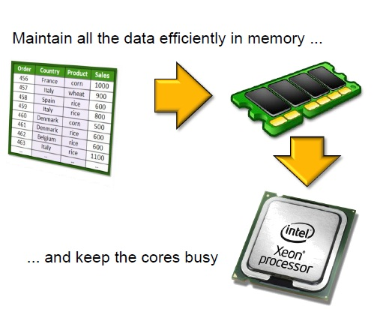

**SAP HANA Architecture**

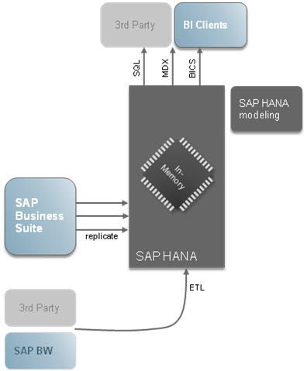  
With the help of technology like SLT replication, data can be moved to HANA in real time. It is also possible to copy data from SAP BW or other database into SAP HANA. In HANA, we can use modeling tool called HANA Studio to build the logic and structures and use tools e.g. SAP BusinessObjects, SAP Visual Intelligence to visualize or analyze data.

**Top 10 Reasons Customers Choose SAP HANA**

SAP HANA is one of the fastest growing products in SAP’s history and is viewed by the industry as a break through solution for in-memory databases. SAP HANA claims that it accelerates analytics and applications on a single, in-memory platform as well as combining databases, data processing, and application platform capabilities.   
  
SAP HANA is a next-generation business platform which brings together

* + Business transactions
  + Advanced analytics
  + Social media
  + Mobile experience
  + Collaborative business
  + Design connections

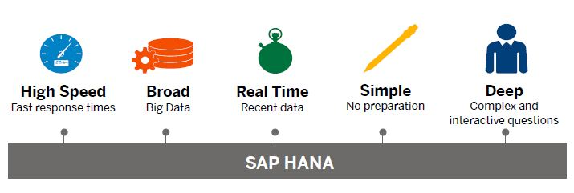  
You may be thinking, “So what?” or “How does this help my business?” or “How can SAP HANA help my company make more money?”   
In this article, we look at what we consider to be the top 10 reasons why customers should choose SAP HANA.

**1. Speed:**

“The speed SAP HANA enables is sudden and significant, and has the potential to transform entire business models.”

SAP HANA manages massive data volume at high speeds.   
It delivers the “real” real-time enterprise through the most advanced in-memory technology.   
SAP HANA provides a foundation on which to build a new generation of applications, enabling customers to analyze large quantities of data from virtually any source, in real time.   
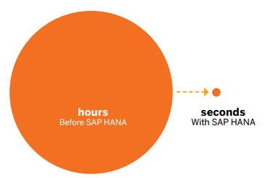  
A live analysis by a consumer products company reveals how SAP HANA analyzes current point-of-sale data in real time—empowering this organization to review segmentation, merchandising, inventory management, and forecasting information at the speed of thought.   
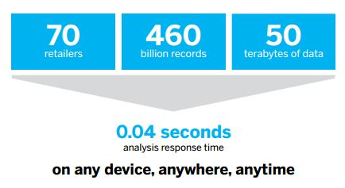

**2. Real Time:**

SAP HANA delivers the “real” real-time enterprise through the most advanced in-memory technology   
  
Pull up-to-the-minute data from multiple sources. Evaluate options to balance financial, operational, and strategic goals based on today’s business

**3. Any Data:**

SAP HANA helps you to gain insights from structured and unstructured data.   
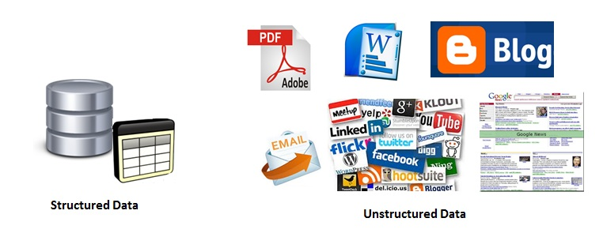  
SAP HANA integrates structured and unstructured data from internal and external sources, and can work on detailed data without aggregations.

**4. Any Source:**

**SAP HANA provides multiple ways to load your data from existing data sources into SAP HANA.**   
  
SAP HANA can be integrated into a wide range of enterprise environments, allowing it to handle data from Oracle databases, Microsoft SQL Server, and IBM DB2.

**5. Insight - Unlock new insights with predictive, complex analysis:**

Before SAP HANA, analytics meant:

* + Preconfigured dashboards based on fixed business requirements.
  + Long wait times to produce custom reports.
  + Reactive views and an inability to define future expectations.

With SAP HANA, you can:   
  
Quickly and easily create ad-hoc views without needing to know the data or query type - allowing you to formulate your actions based on deep insights   
  
  
Receive quick reactions to newly articulated queries so you can innovate new processes and business models to outpace the competition.  
  
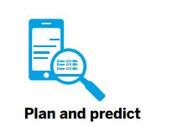  
Enable state-of-the-art, interactive analyses such as simulations and pattern recognition to create measurable, targeted actions.

**6. Innovation - The ultimate platform for business innovation:**

SAP HANA is an early innovator for in-memory computing. Its configurability, easy integration, and revolutionary capabilities make it flexible enough for virtually anything your business requires.   
  
Some examples of this include:   
  
**Energy Management**   
  
Utility companies use SAP HANA to process and analyze vast amounts of data generated by smart meter technology, improving customers’ energy efficiency, and driving sustainability initiatives.   
**Real-time Transit Routing**   
  
SAP HANA is helping research firms calculate optimal driving routes using real-time GPS data transmitted from thousands of taxis.   
**Software Piracy Detection and Prevention**   
  
Tech companies use SAP HANA to analyze large volumes of complex data to gain business insights into software piracy, develop preventive strategies, and recover revenue.

**7. Simplicity - Fewer layers, simpler landscape, lower cost:**

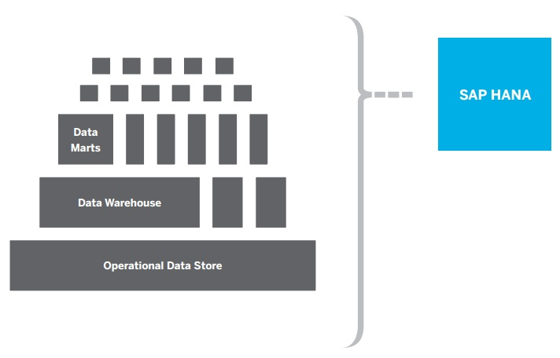  
**Reduce or eliminate** the data aggregation, indexing, mapping and exchange-transfer-load (ETL) needed in complex data warehouses and marts.   
  
**Incorporate** prepackaged business logic, in-memory calculations and optimization for multicore 64-bit processors.   
  
**Spend less** on real-time computing

**8. Cloud:**

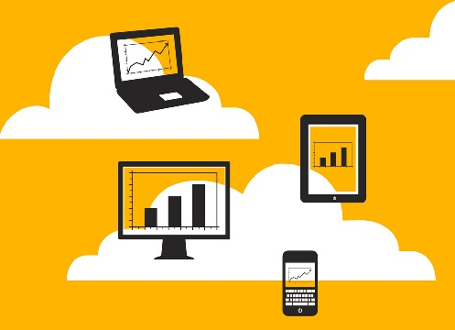  
**Step up to one of the world’s most advanced clouds.**   
SAP HANA powers SAP’s next- generation enterprise cloud.   
  
**Fast:**  
  
A single-location stack removes latency – enabling real-time collaboration, processing, and planning.   
**Scalable:**  
  
A highly robust cloud service allows quick deployment of current and next generation applications, scaled to your business needs.   
**Secure:**  
  
We secure your data through the entire cloud solution with independently audited standards of data security and governance.

**9. Cost:**

SAP HANA reduces your total IT cost so you can increase spending on innovation.

**10. Choice:**

SAP HANA provides you choice at every layer to work with your preferred partners.

* + **Run on the hardware of your choice.**
  + **Work with the software you prefer.**

Collaboration with a number of partners means that SAP can complete the software stacks of our diverse customer base in configurations that make sense for their business.   
Plus, a variety of different options means that you won’t be locked in by a single provider.   
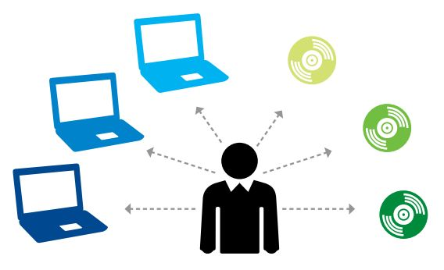

# Get Your own HANA DB

## Get Free Access To SAP HANA Server:

You can get your own HANA DB server , running on Amazon Web Services. No license fee, you just pay AWS for the hosting cost.   
  
If running your own HANA on AWS sounds like too much of an investment for now, there is even a completely free option - SAP HANA Cloud Platform. Check the article Get Free Access to HANA Cloud Platform for more details.

# SAP HANA Hardware

SAP HANA is a combination of hardware and software made to process massive real time data using In-Memory computing. To leverage the full power of the SAP HANA platform, you need the right hardware infrastructure.   
  
The SAP HANA can only be installed and configured by certified hardware partners.

## SAP HANA Hardware Partners:

Currently SAP HANA Hardware partners are:  
HP, FUJITSU,CISCO, IBM, HITACHI, NEC and DELL.   
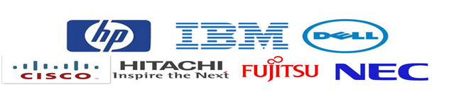

**SAP HANA Database:**

SAP HANA is an in-memory database:

* + - - It is a combination of hardware and software made to process massive real time data using In-Memory computing.
    - - It combines row-based, column-based database technology.
    - - Data now resides in main-memory (RAM) and no longer on a hard disk.
    - - It’s best suited for performing real-time analytics, and developing and deploying real-time applications.

An in-memory database means all the data is stored in the memory (RAM). This is no time wasted in loading the data from hard-disk to RAM or while processing keeping some data in RAM and temporary some data on disk. Everything is in-memory all the time, which gives the CPUs quick access to data for processing.   
  
The speed advantages offered by this RAM storage system are further accelerated by the use of multi-core CPUs, and multiple CPUs per board, and multiple boards per server appliance.   
  
Complex calculations on data are not carried out in the application layer, but are moved to the database.   
  
SAP HANA is equipped with multiengine query processing environment which supports relational as well as graphical and text data within same system. It provides features that support significant processing speed, handle huge data sizes and text mining capabilities.